Name : K Subrahmanyam
Redg No : 192312521
ITA0602 – MACHINE LEARNING
SDG 2 ASSIGNMENT
Q14. Challenges in Representing Multi-Modal Data for Wildfire Prediction
Question: Explain the challenges in representing multi-modal data (satellite imagery + weather data) as neural network inputs for wildfire prediction systems. (SDG 15 – Life on Land).
Introduction
Wildfires are influenced by several factors such as vegetation condition, land characteristics, temperature, humidity, rainfall, and wind. A wildfire prediction system can combine satellite imagery and weather data to predict the possibility of a wildfire.
Satellite images provide visual information about the land and vegetation, while weather data provides numerical information about environmental conditions. Since these two types of data are very different, representing them together as inputs to a neural network creates several challenges.
Basic Representation
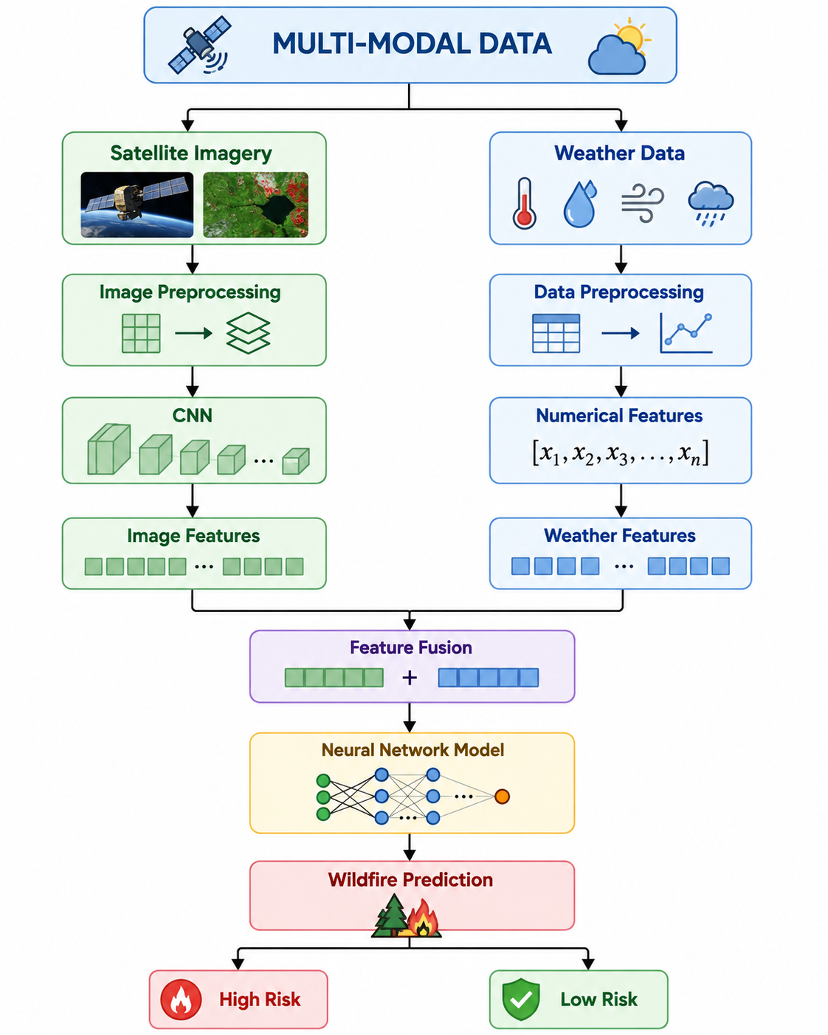
1. Different Data Formats
The first challenge is that satellite images and weather data have different formats.
Satellite imagery consists of pixels and may contain multiple spectral bands. It can provide information about:
- Vegetation
- Land cover
- Dry areas
- Burned regions
Weather data is generally numerical or time-series data, such as:
- Temperature
- Humidity
- Wind speed
- Rainfall
Therefore, both data types cannot be directly combined. They need separate preprocessing and feature extraction.

2. Different Spatial Scales
Satellite imagery usually represents a large geographical area, whereas weather stations may provide measurements at only specific locations.
For example:
Satellite Image
Weather Sensor
One Location
The model must determine which weather measurements correspond to the geographical region represented in the satellite image.

3. Different Time Scales
Another important challenge is the difference in time of data collection.
A satellite image may be captured once at a particular time, while weather data may be collected every few minutes or hours.
For example:
Satellite Image → 10:00 AM
Weather Data → 10:00 AM, 10:15 AM, 10:30 AM...
If the data is not properly synchronized, the model may associate a satellite image with incorrect weather conditions.
Therefore, temporal alignment is necessary.

4. Missing and Noisy Data
Both sources may contain incomplete or noisy information.
Satellite images can be affected by:
- Clouds
- Smoke
- Atmospheric conditions
- Sensor noise
Weather data may contain:
- Missing readings
- Sensor errors
- Incorrect measurements
- Sudden abnormal values
Such data must be cleaned before being supplied to the neural network.

5. Feature Extraction
Different methods are required to extract useful information from each modality.
For satellite images, a Convolutional Neural Network (CNN) can extract spatial features such as vegetation patterns and land characteristics.
For weather data, numerical features can be directly processed after normalization.
Satellite Image → CNN → Image Features
│
↓
Feature Fusion
↑
│
Weather Data → Preprocessing → Weather Features

6. Feature Fusion
After extracting features from both sources, they need to be combined into a common representation.
This process is called feature fusion.
For example:
The challenge is to combine them without allowing one type of data to dominate the other.
A good fusion method can help the model learn relationships between land conditions and weather conditions.

7. High-Dimensional Satellite Data
High-resolution satellite images can contain a very large number of pixels and multiple spectral bands.
This produces a large number of input features.
As a result:
- Training becomes computationally expensive.
- More memory is required.
- Training time increases.
- The model may overfit if sufficient training data is not available.
Feature extraction and dimensionality reduction can help address this problem.

8. Different Data Reliability
Satellite data and weather data may not always have the same reliability.
For example, cloud cover may hide important areas in a satellite image, while a weather sensor may provide accurate temperature information.
Therefore, the neural network should be able to handle situations where one modality is incomplete or less reliable.

9. Computational Complexity
Combining high-resolution satellite images with continuous weather information increases the complexity of the neural network.
The system may require:
- Large datasets
- High computational power
- More memory
- Longer training time
Therefore, efficient preprocessing and model design are important.

Possible Solution
A suitable solution is to process the two data types separately and combine them later.
This approach allows the neural network to learn visual features from satellite images and environmental patterns from weather data before combining them.
